**Knowledge share:**

Contents

**Kmart & EPS-Kmart Analysis** 1

**Daily Performance Analysis** 3

**LSR Power BI** 4

**Kmart trouble shoot** 5

A few sites to look for Power BI details:

Basic DAX: <https://docs.microsoft.com/en-us/power-bi/desktop-quickstart-learn-dax-basics>

Power BI connectors: <https://docs.microsoft.com/en-us/azure/devops/report/powerbi/data-connector-connect?view=azure-devops&viewFallbackFrom=vsts>

Power BI community: <https://community.powerbi.com/>

# **Kmart & EPS-Kmart Analysis**

1. Kmart repo: <https://mseng.visualstudio.com/AzureDevOps/_git/Tools.Kmart>
2. Connect Power BI with Kmart0 database: since we need to do percentile of the data, we can’t really use the DirectQuery way, because it doesn’t support certain calculation functions. And we are doing manual refresh now, because if we need to do auto refresh on Import mode, we will need to install Gateway on Kmart servers. 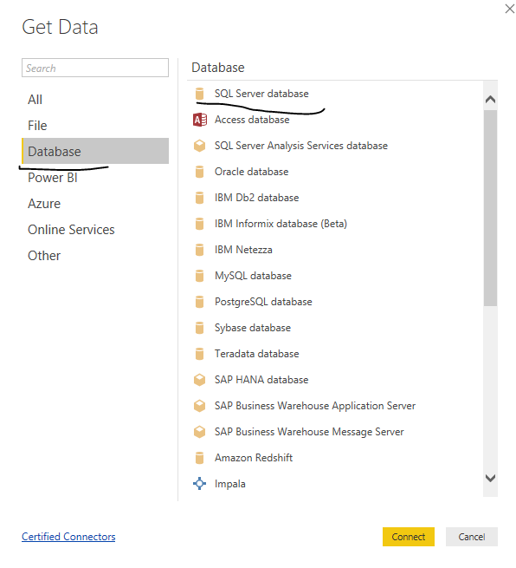

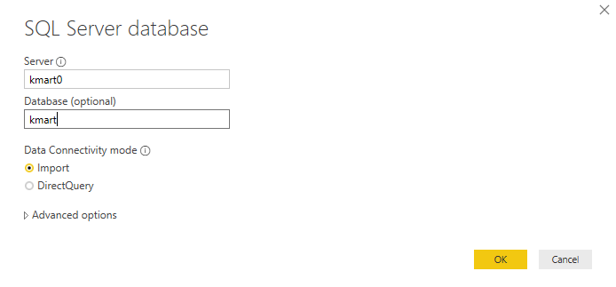

1. In Power BI

* Refresh: allows you to refresh the latest row data
* Publish: once you have complete modify, you can publish to AzureDevOps work space. You can simply override the existing one, but make sure, you did not mass up the report.
* Visualization: is all the available visualizations you can use, there’s more you can import.
* Format tab: allows you to change the format
* Filters: there are many levels of filter here
* Fields: are the tables of data we need. You can add more measures and columns to it.
* Edit Queries: allows you to modify the query of your raw data. Ex: only load the past 30 days’ data

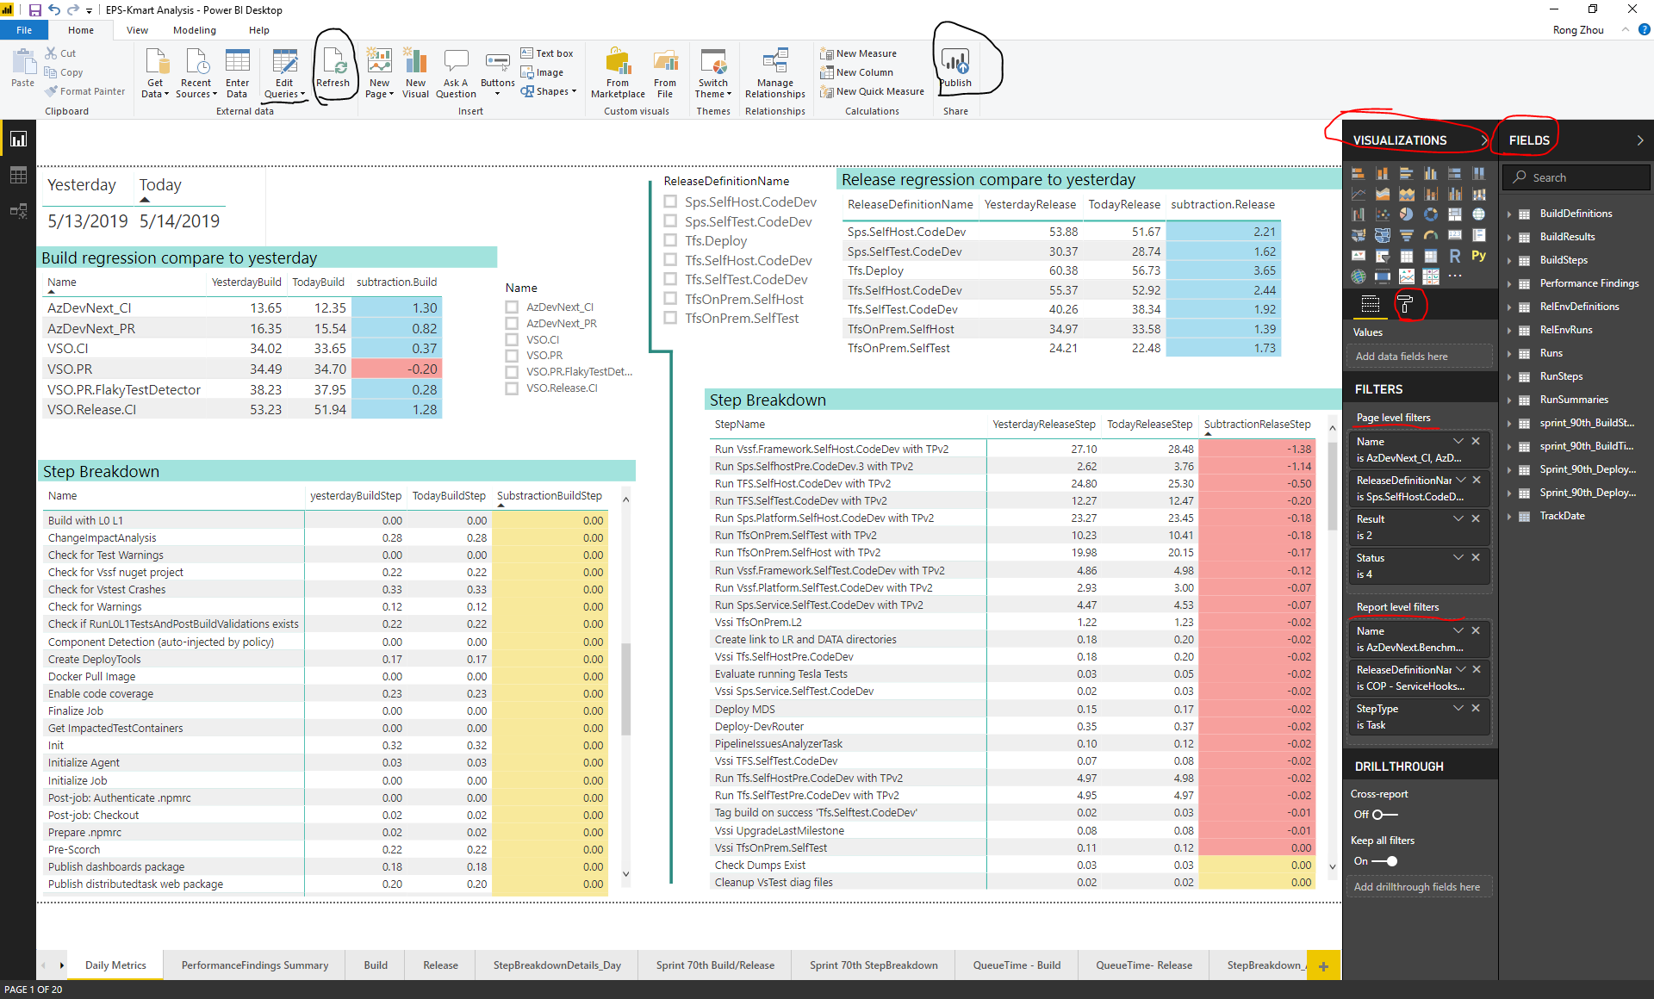

# **Daily Performance Analysis**

1. First thing to do in the morning, Refresh the EPS-Kmart Analysis
2. There are multiple pages in this BI. I have the most used page on the left, and least on the right. First clue is the Daily Metric. Check each and every Build&Release definitions. See if they have big regression.

* For PR & Cis & all P0 Release definitions we need to look into anything regressed or improved by around 1 min.

1. If you see any outstanding change in the duration, next step is to look at the Build or Release tab, which have the details in step time trends.
2. There is also other useful pages.

* **Daily Metrics:** 70th percentile comparing from previous day to the day before, the page is set to not include weekends
* **Build:** Build Time details for builds and build steps for past N days
* **Release :** Release Time details for the Runs and run steps for past N days
* **StepBreakdownDetails_Day :** steps 70 percentile details per past N days
* **Sprint 70th Build/Release :** numbers come directly from database views:

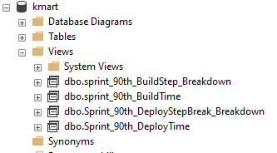

* **Sprint 70th StepBreakdown:** sprint level step time detail break downs
* **QueueTime – Build:** Queue time for builds, with details and 90 percentile per day
* **QueueTime- Release:** Queue time for releases, with details and 90 percentile per day.
* **StepBreakdown_Agent :** for builds with agent breakdown details.
* **vssdf success rate:** Gaurav requested specific use page
* **7days Benchmark review:** Krishna requested specific use page
* **Every 7 days step by agent:** For PR & CIs, every 7 days of step/Agent breakdown heat map
* **Day level:** Gaurav requeusted page
* **Sprint level:** Gaurav requested page

1. Add the details into the excel sheet to track all the history of issues, called “Performance finding”. Different color represent status of the finding as below:

|  |  |  |  |
| --- | --- | --- | --- |
| improved | issues | no action needed | regressed, then fixed/improved back |

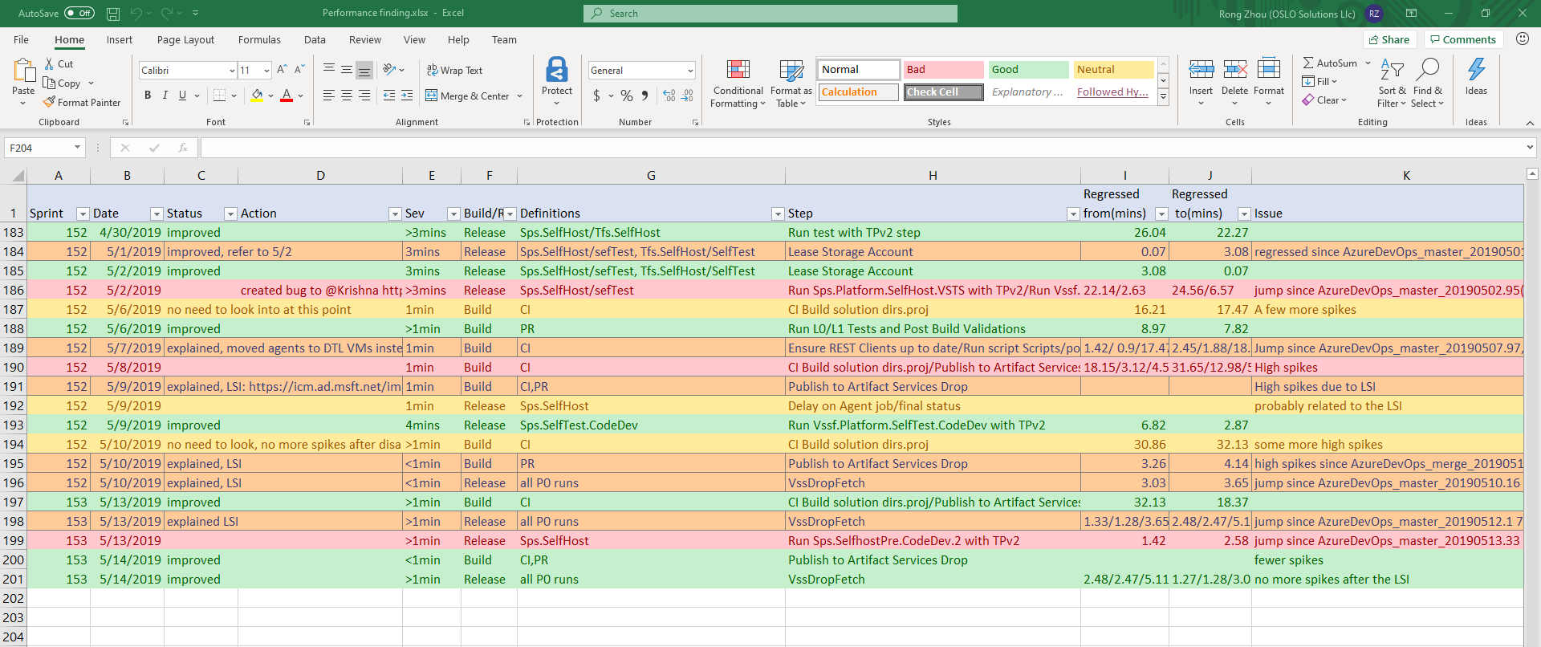

1. Once you think the daily analysis is done, publish the latest data, so that people can look at the data in Teams.

# **LSR Power BI**

1. LSR BI is getting data from mseng analytics service. Here are the views. I created this “bugs for LSR” specific for EPS LSR report use. <https://dev.azure.com/mseng/AzureDevOps/_analytics>. You can edit if you need more fields in the future.
2. For each previous sprint, make sure the following data is all correct:

* Bugs with Sev 0-2 should be all included
* There should not be any bug with blank symptoms
* All bugs should be assigned to the right owner
* Make sure the time occur/ detect/mitigate, and the hit counts are all correct
* Bugs should not have two with exactly the same name
* Make sure for the past sprint, all bugs for BMOD include tags “BMOD” and “CI_Reliability”, otherwise it won’t be picked up by the query we use.

1. LSR BI is set automatically refreshed every other hour. But you can also manually refresh it. There are two ways to do that:

Download the .pbix file to your local and use Power Bi Desktop to refresh and push to server.

Refresh on the website: <https://msit.powerbi.com/groups/cd2504a9-b748-4087-b3f9-60c46b6f1782/list/datasets>

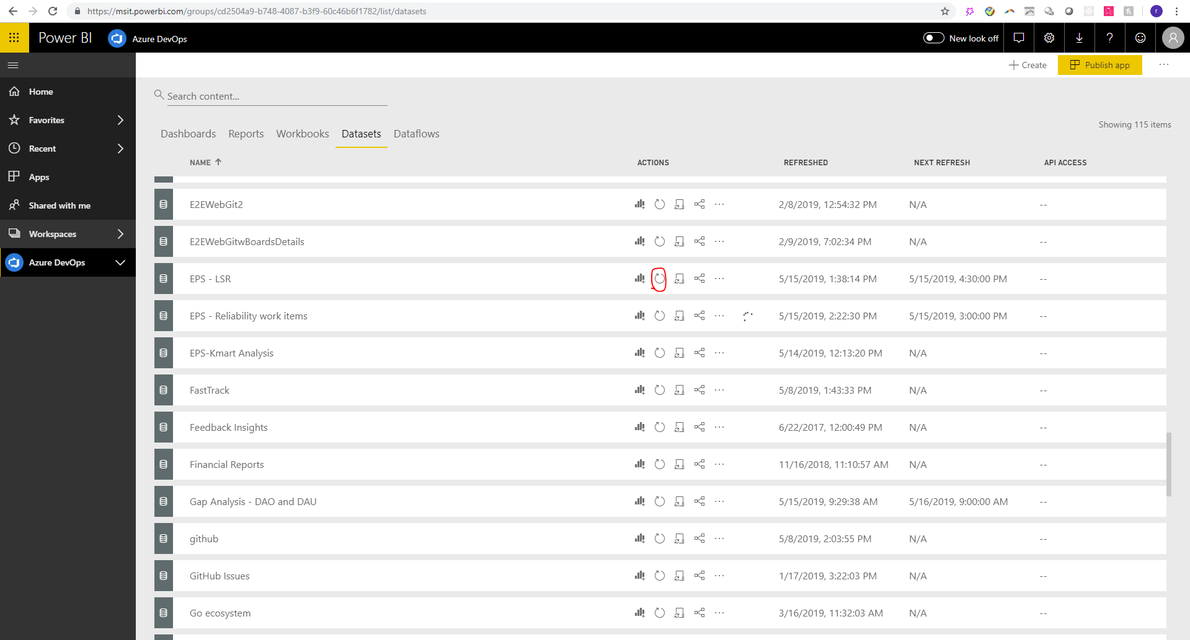

# **Kmart trouble shoot**

If you see Kmart alert email, first take a look of the error message in the email. If it says “Service Unavailable at ….” that means it’s the Mseng service issue. You can just ignore that. If it’s something else, you will need to look into.

1. Go to Kmart0 server, c drive the logs. Look at the latest log and the detailed error message.
2. Then go check the Kmart code, particularly pay attention to the data format issues. Most of the time the error will be caused by the data, either new data fields or not correct format.
3. If you need to change the data model, refer to this one note page: [Upgrading the database (Migrations)](onenote:https://microsoft.sharepoint.com/teams/DD_VSCS/EPS/Documents/EPS%20OneNote/Tools.one#Upgrading%20the%20database%20(Migrations)%20&section-id={3788A4C2-AC8F-4185-8B01-6DFE2B7C776F}&page-id={919882A2-5D7B-4C26-A19B-2BF897096ED3}&end)  ([Web view](https://microsoft.sharepoint.com/teams/DD_VSCS/EPS/_layouts/OneNote.aspx?id=%2Fteams%2FDD_VSCS%2FEPS%2FDocuments%2FEPS%20OneNote&wd=target%28Tools.one%7C3788A4C2-AC8F-4185-8B01-6DFE2B7C776F%2FUpgrading%20the%20database%20%28Migrations%5C%29%7C919882A2-5D7B-4C26-A19B-2BF897096ED3%2F%29)) else ask Laurence to get more info.